Concept Of Effective and Efficient building

**Passive energy system design**

* Passive Design won’t use any outside energy or require much special equipment, but simply takes advantage of existing natural phenomena, like the direction of the sun or the insulating properties of building materials.
* Passive Design does not require mechanical heating or cooling.

**Results:** when a building is created and simply works “on its own”. Solar passive buildings are designed to achieve thermal and visual comfort by using natural energy resources.

**Role of Passive Energy in Architecture**

* Passive in architecture regards the particular way to construct a building using the, natural movement of heat and air, passive solar gain and cooling in order to maintain a good internal comfort.
* Through the use of passive design, it is possible to eliminate, or at least reduce, the use of mechanical systems and the energy demand by 80% as well as the CO2 emissions.

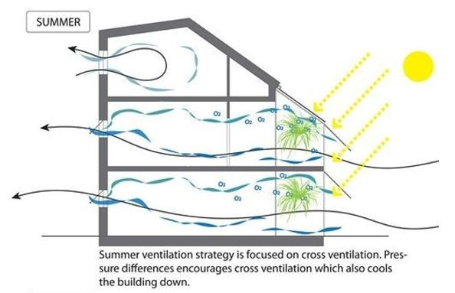**Passive solar design**

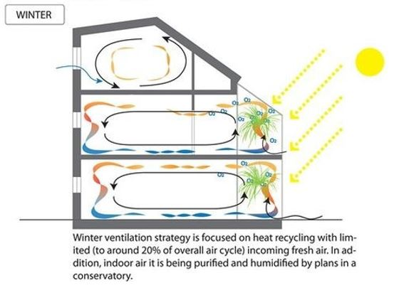

* 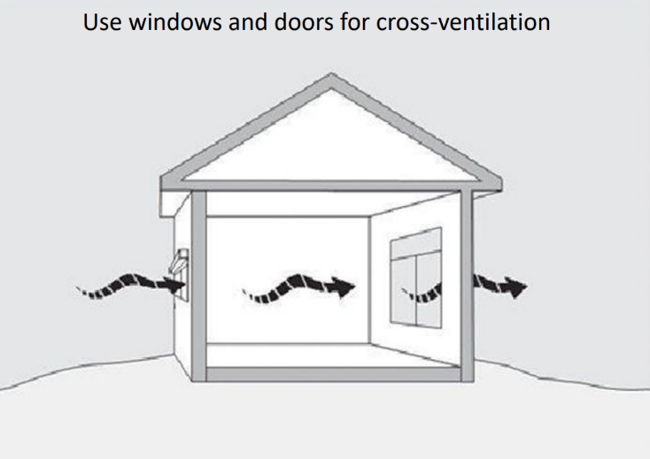Passive design strategies use ambient energy sources instead of purchased energy like electricity or natural gas. These strategies include day lighting, natural ventilation, and solar energy.

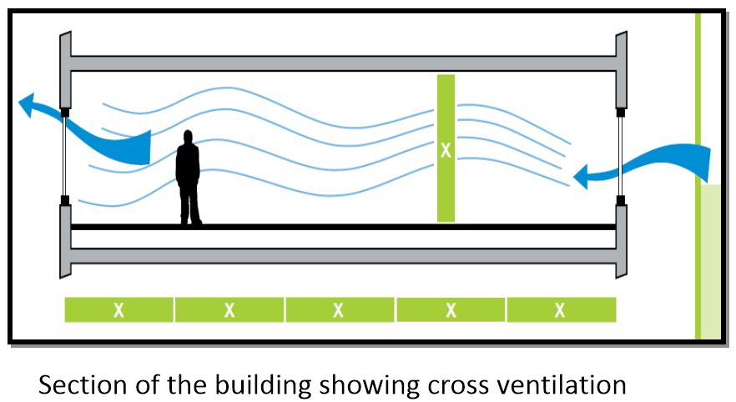

**Sun movement in summer and winter**

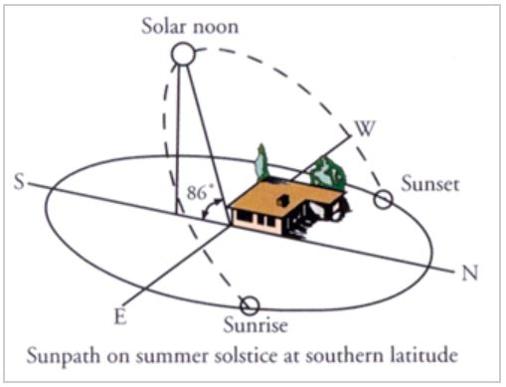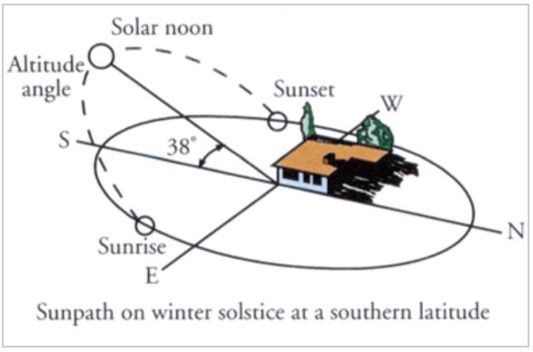

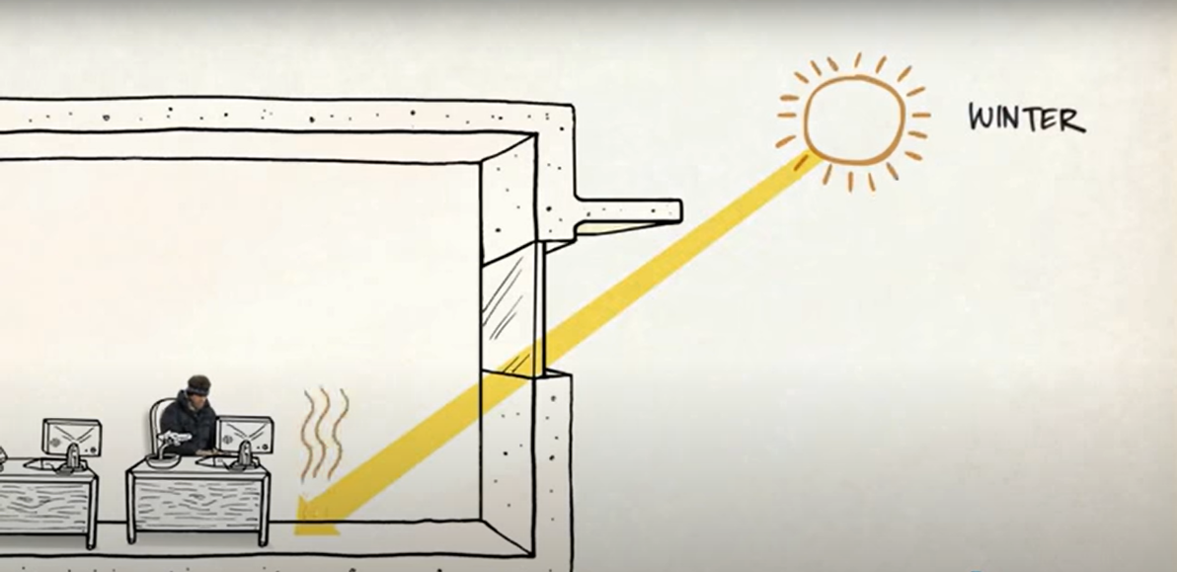

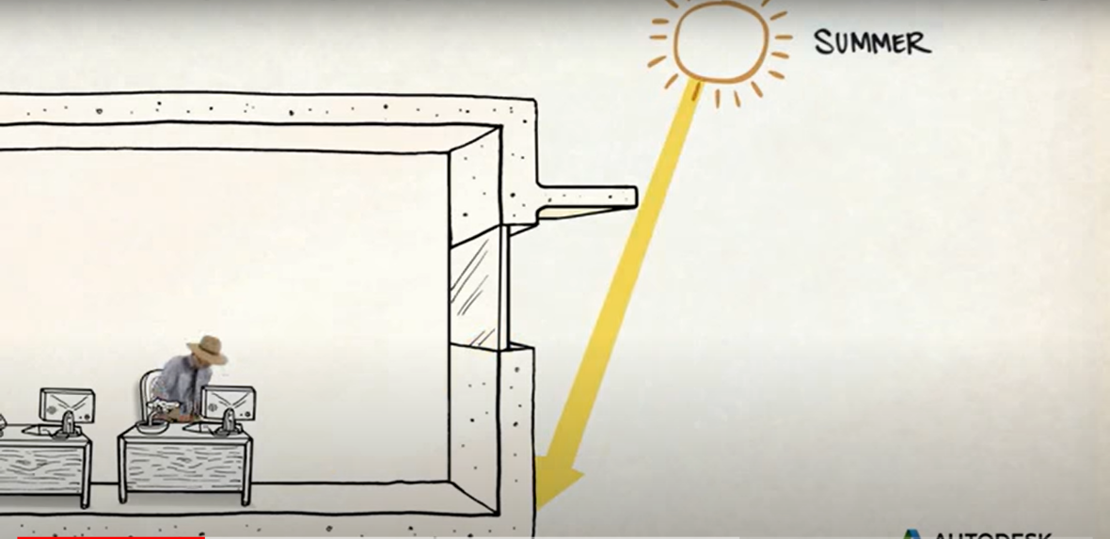

**CONDUCTION**

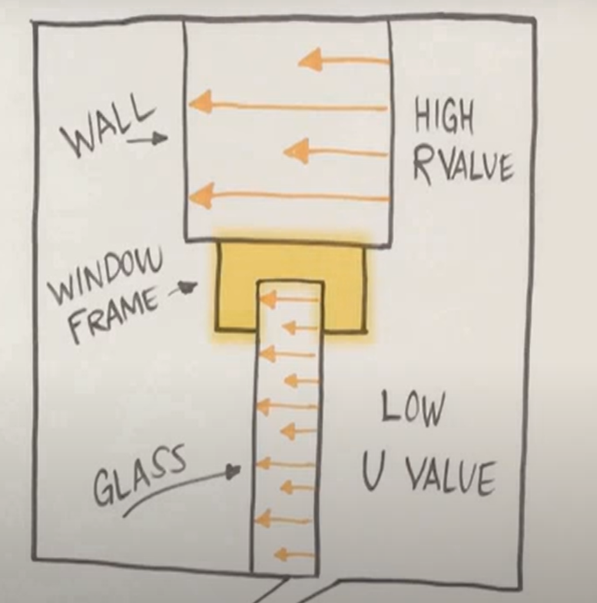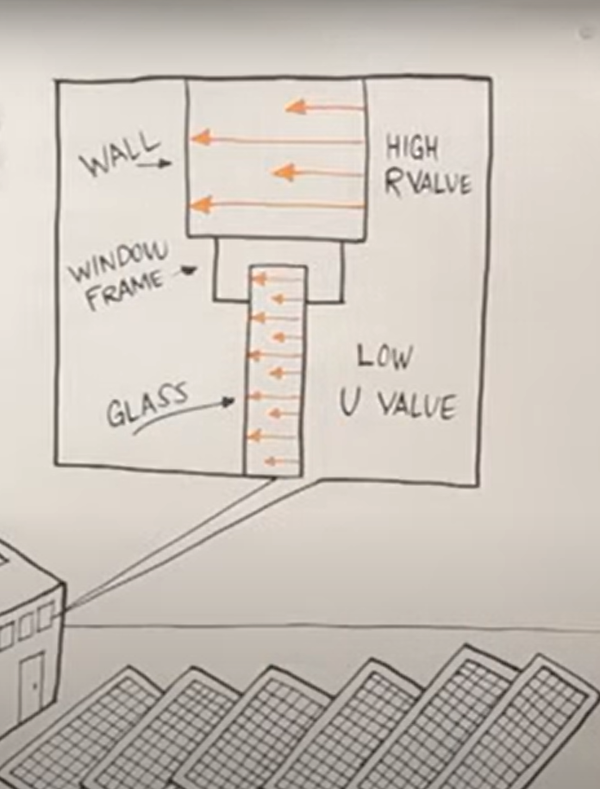The process of transfer of heat through the material is known as conduction. Pleasr refer to the r values and U values which are menctioned in the pdf offered in this course.

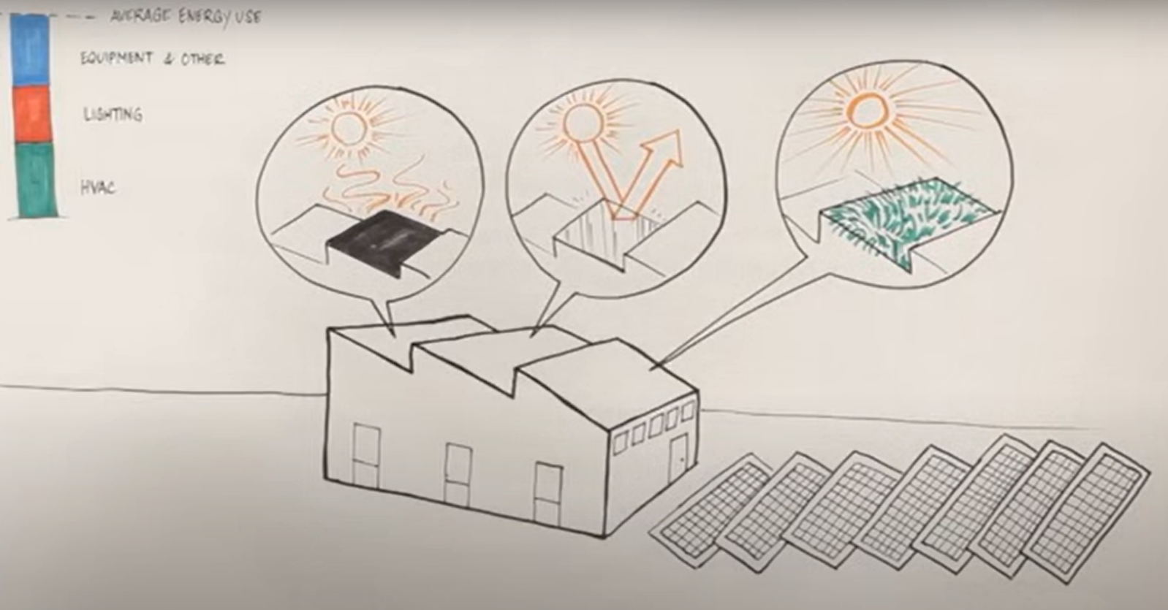

The major sources where sun heats buildings are duct roofs and pavements above fig discribes how those heat gaining parameters can be optimized with alternative roofing system.

**Role Of Windows in Efficient Building And Their Types, Standards**

**Exterior window shading strategy**.

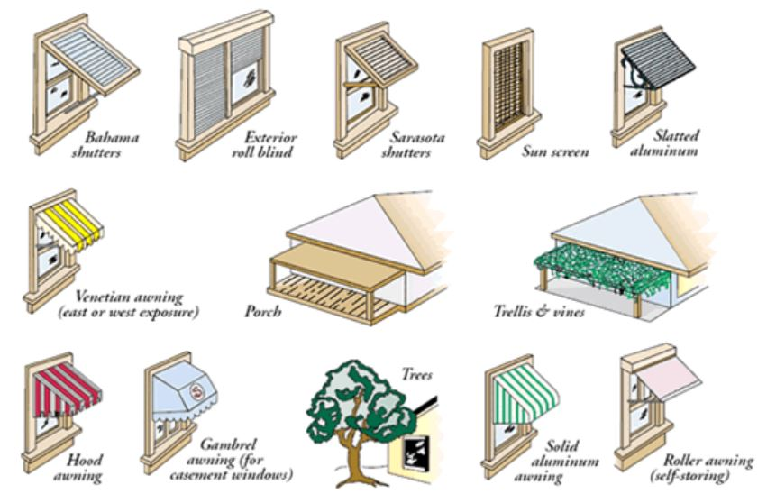

**Window to Wall Ratio (WWR)**

The optimal window to external wall ratio was 40% and 60% for recedential building.

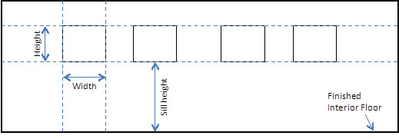

The Window-to-Wall Ratio (WWR) is the fraction of the above grade wall area that is covered by fenestration, calculated as the ratio of the wall fenestration area to the gross above grade wall area.

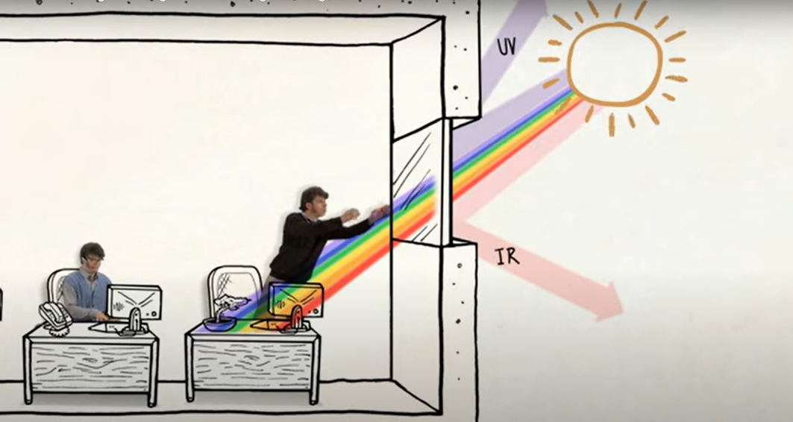

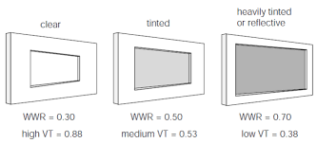

**TYPES OF PASSIVE ENERGY WINDOWS**

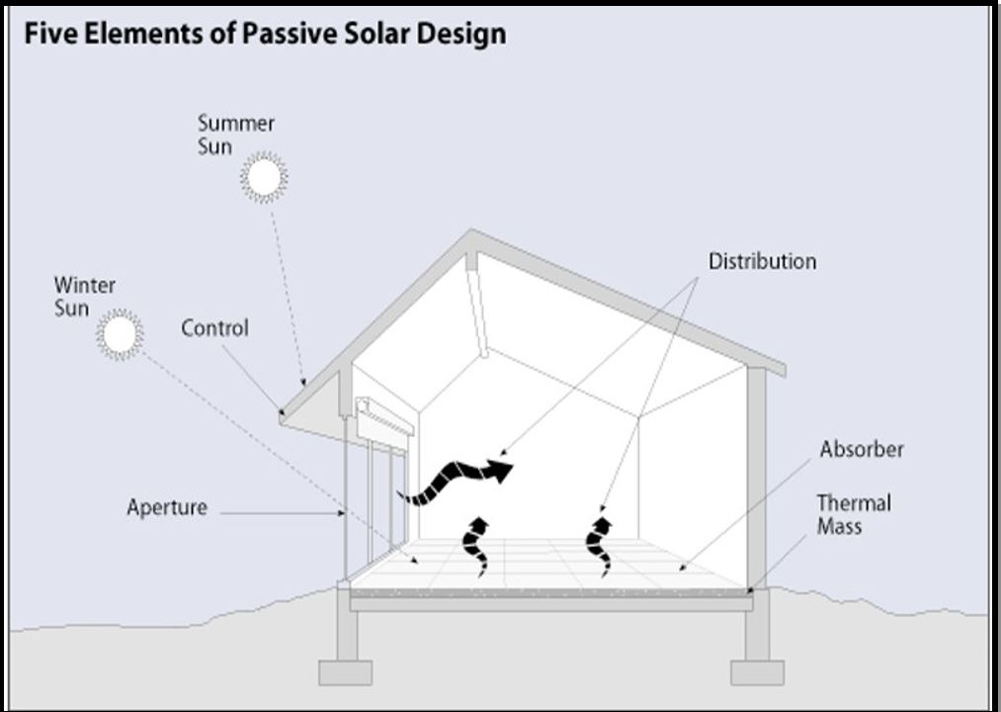

* Installing skylights, highly-placed clerestory windows, and/or solar tubes (also known as light tubes) to help illuminate naturally darker rooms.
* Incorporating reflective surfaces like light shelves, which help reflect sunlight coming in through a window up toward the ceiling**.**

**SKY LIGHTING:**

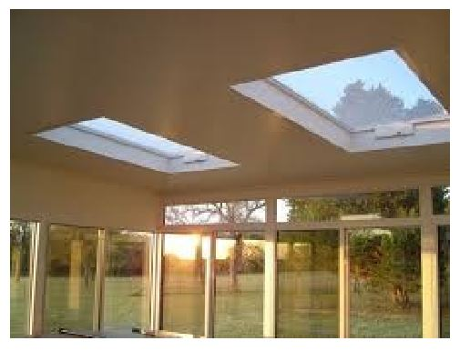 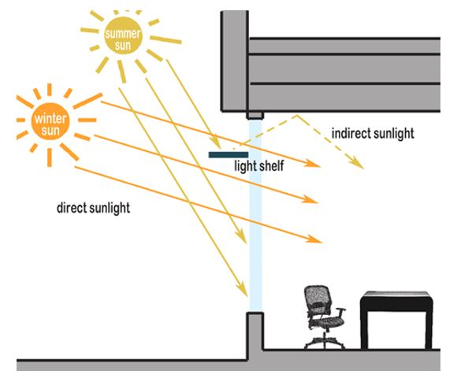

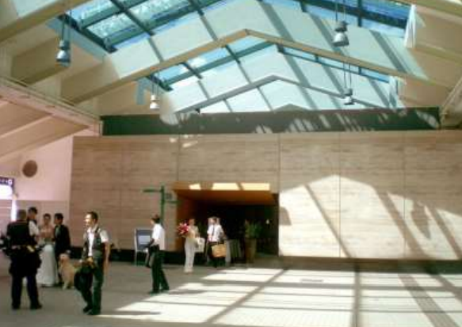

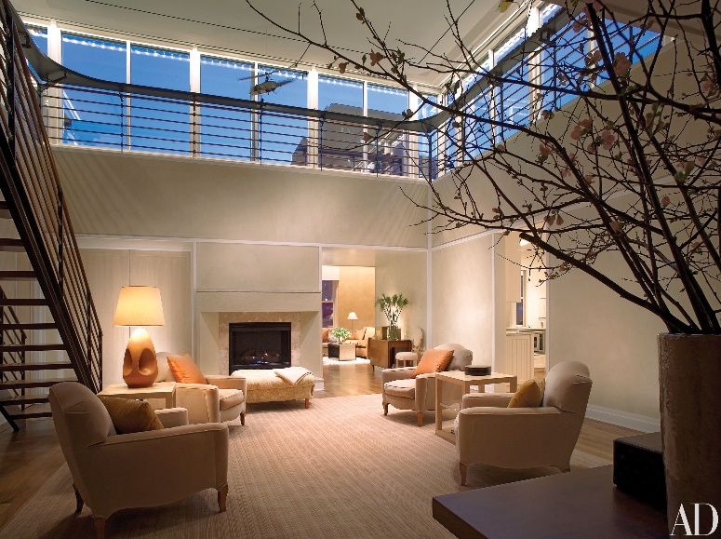 **CLERSTOREY :**

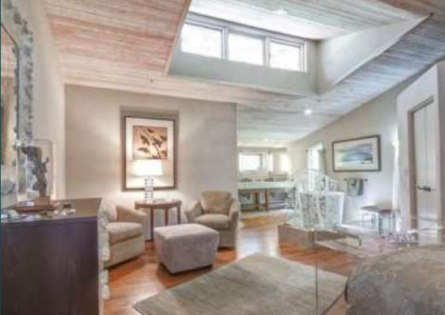

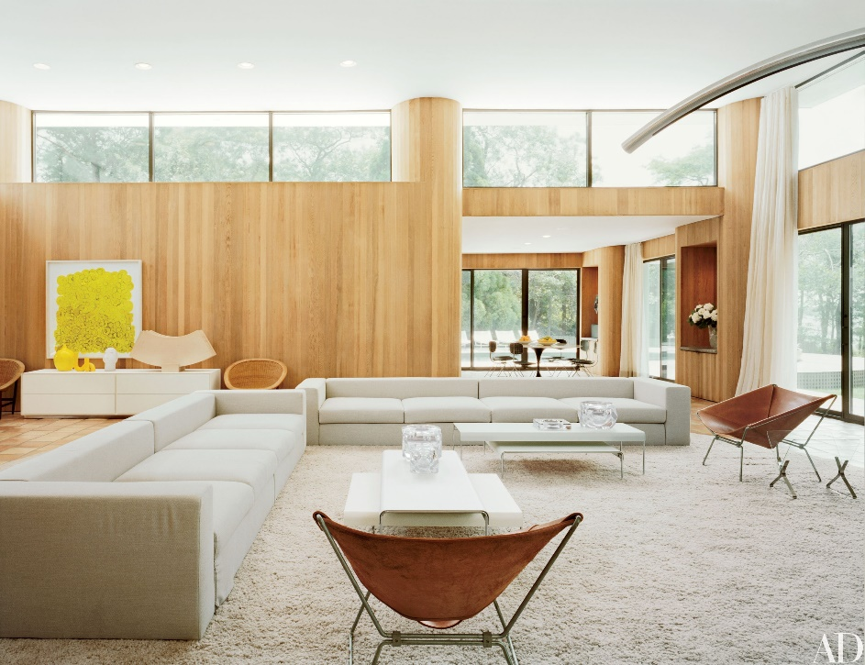

**MONITOR LIGHTING :**

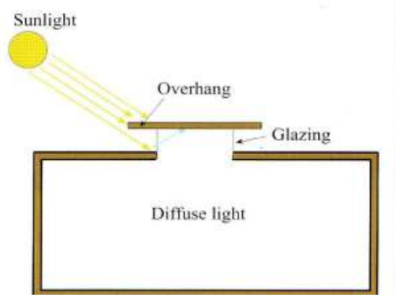

**SAW TOOTH LIGHTING :**

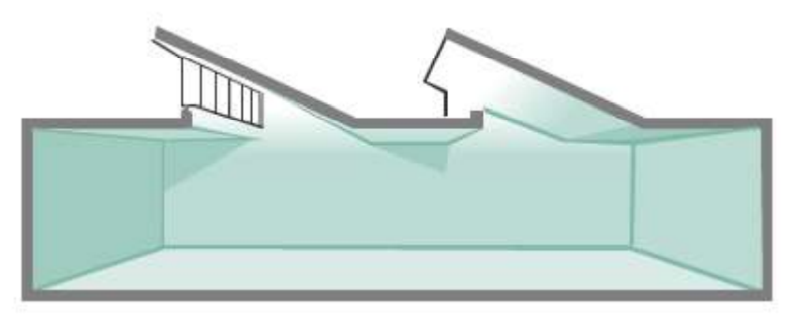

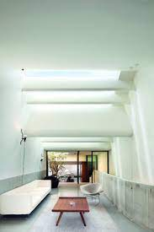

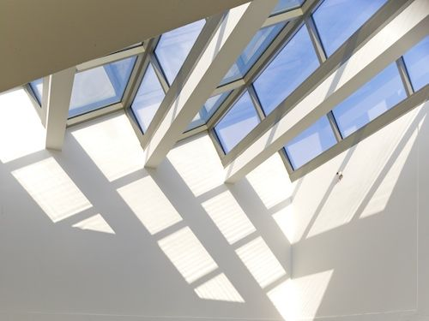

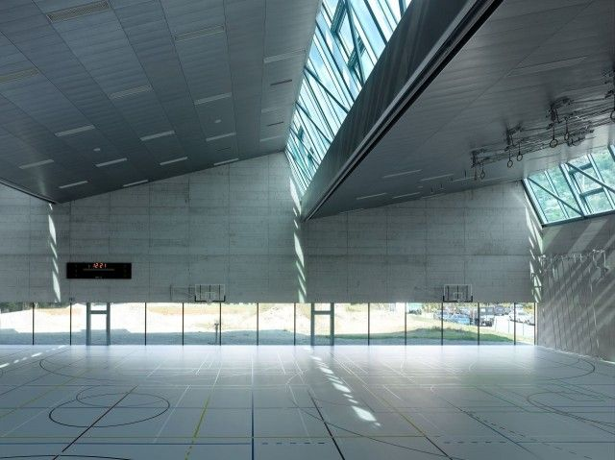

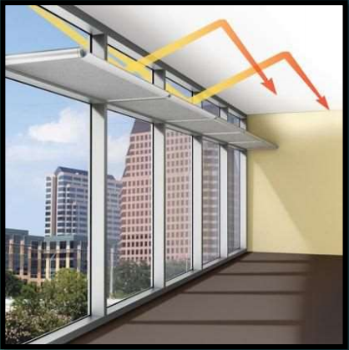**LIGHT SHELVES**:

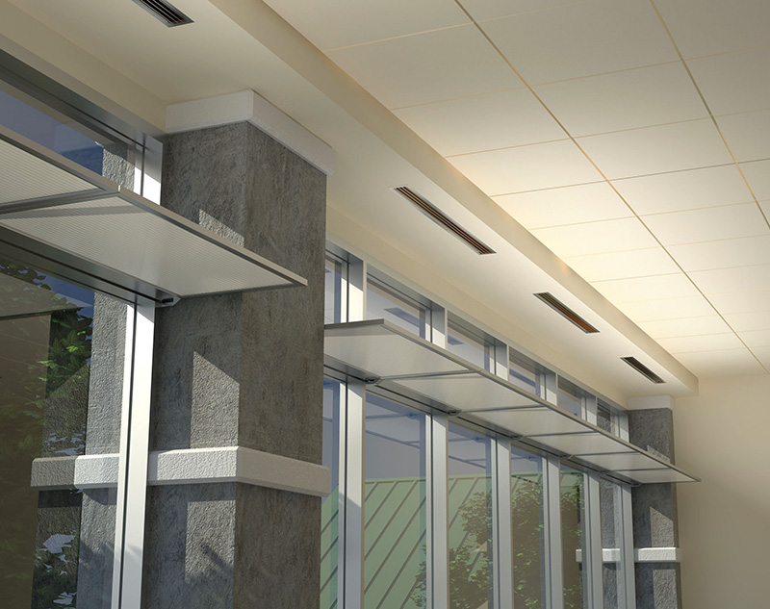

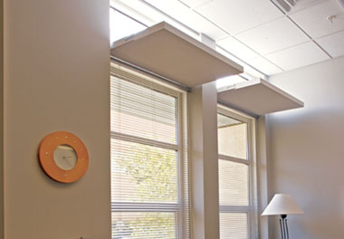

**SOLAR/LIGHT TUBES**:

